UNIT 2
Block Diagram of Computer

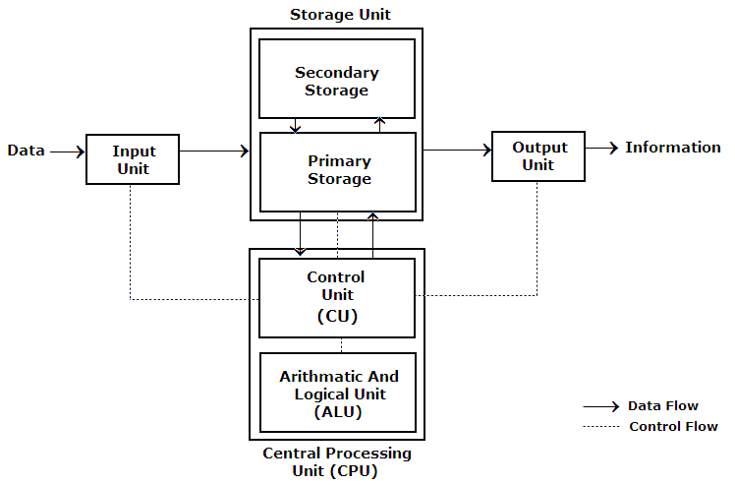

1. Input: This is the process of entering data and programs in to the computer system. You should know that computer is an electronic machine like any other machine which takes as inputs raw data and performs some processing giving out processed data. Therefore, the input unit takes data from us to the computer in an organized manner for processing.

2. Storage: The process of saving data and instructions permanently is known as storage. Data has to be fed into the system before the actual processing starts. It is because the processing speed of Central Processing Unit (CPU) is so fast that the data has to be provided to CPU with the same speed. Therefore the data is first stored in the storage unit for faster access and processing. This storage unit or the primary storage of the computer system is designed to do the above functionality. It provides space for storing data and instructions.

The storage unit performs the following major functions:

• All data and instructions are stored here before and after processing.

• Intermediate results of processing are also stored here.

3. Processing: The task of performing operations like arithmetic and logical operations is called processing. The Central Processing Unit (CPU) takes data and instructions from the storage unit and makes all sorts of calculations based on the instructions given and the type of data provided. It is then sent back to the storage unit.

4. Output: This is the process of producing results from the data for getting useful information. Similarly the output produced by the computer after processing must also be kept somewhere inside the computer before being given to you in human readable form. Again the output is also stored inside the computer for further processing.

5. Control: The manner how instructions are executed and the above operations are performed. Controlling of all operations like input, processing and output are performed by control unit. It takes care of step by step processing of all operations inside the computer.

FUNCTIONAL UNITS
In order to carry out the operations mentioned in the previous section the computer allocates the task between its various functional units. The computer system is divided into three separate units for its operation. They are

Arithmetic Logical Unit (ALU)
Logical Unit :After you enter data through the input device it is stored in the primary storage unit. The actual processing of the data and instruction are performed by Arithmetic Logical Unit. The major operations performed by the ALU are addition, subtraction, multiplication, division, logic and comparison. Data is transferred to ALU from storage unit when required. After processing the output is returned back to storage unit for further processing or getting stored.

Control Unit (CU)
The next component of computer is the Control Unit, which acts like the supervisor seeing that things are done in proper fashion. Control Unit is responsible for co ordinating various operations using time signal. The control unit determines the sequence in which computer programs and instructions are executed. Things like processing of programs stored in the main memory, interpretation of the instructions and issuing of signals for other units of the computer to execute them. It also acts as a switch board operator when several users access the computer simultaneously. Thereby it coordinates the activities of computer’s peripheral equipment as they perform the input and output.

Central Processing Unit (CPU)
The ALU and the CU of a computer system are jointly known as the central processing unit. You may call CPU as the brain of any computer system. It is just like brain that takes all major decisions, makes all sorts of calculations and directs different parts of the computer functions by activating and controlling the operations.
Input Devices:
Keyboard
Most common and very popular input device is keyboard. The keyboard helps in inputting the data to the computer. The layout of the keyboard is like that of traditional typewriter, although there are some additional keys provided for performing some additional functions.
Keyboards are of two sizes 84 keys or 101/102 keys, but now 104 keys or 108 keys keyboard is also available for Windows and Internet.
The keys are following
Sr. No. | Keys | Description
1 | Typing Keys | These keys include the letter keys (A-Z) and digits keys (0-9) which generally give same layout as that of typewriters.
2 | Numeric Keypad | It is used to enter numeric data or cursor movement. Generally, it consists of a set of 17 keys that are laid out in the same configuration used by most adding machine and calculators.
3 | Function Keys | The twelve functions keys are present on the keyboard. These are arranged in a row along the top of the keyboard. Each function key has unique meaning and is used for some specific purpose.
4 | Control keys | These keys provide cursor and screen control. It includes four directional arrow key. Control keys also include Home, End, Insert, Delete, Page Up, Page Down, Control(Ctrl), Alternate(Alt), Escape(Esc).
5 | Special Purpose Keys | Keyboard also contains some special purpose keys such as Enter, Shift, Caps Lock, Num Lock, Space bar, Tab, and Print Screen.
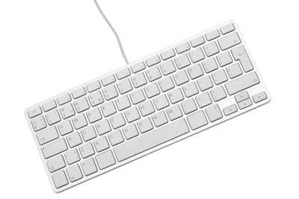
Mouse
Mouse is most popular Pointing device. It is a very famous cursor-control device. It is a small palm size box with a round ball at its base which senses the movement of mouse and sends corresponding signals to CPU on pressing the buttons.
Generally, it has two buttons called left and right button and scroll bar is present at the mid. Mouse can be used to control the position of cursor on screen, but it cannot be used to enter text into the computer.
Advantages
- Easy to use
- Not very expensive
- Moves the cursor faster than the arrow keys of keyboard.
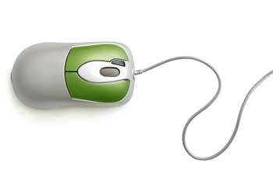
Joystick
Joystick is also a pointing device, which is used to move cursor position on a monitor screen. It is a stick having a spherical ball at its both lower and upper ends. The lower spherical ball moves in a socket. The joystick can be moved in all four directions.
The function of joystick is similar to that of a mouse. It is mainly used in Computer Aided Designing (CAD) and playing computer games.
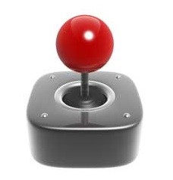
Light Pen
Light pen is a pointing device, which is similar to a pen. It is used to select a displayed menu item or draw pictures on the monitor screen. It consists of a photocell and an optical system placed in a small tube.
When light pen’s tip is moved over the monitor screen and pen button is pressed, its photocell sensing element, detects the screen location and sends the corresponding signal to the CPU.

Track Ball
Track ball is an input device that is mostly used in notebook or laptop computer, instead of a mouse. This is a ball, which is half inserted and by moving fingers on ball, pointer can be moved.
Since the whole device is not moved, a track ball requires less space than a mouse. A track ball comes in various shapes like a ball, a button and a square.
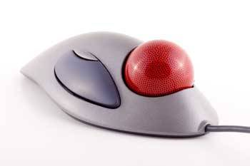
Scanner
Scanner is an input device, which works more like a photocopy machine. It is used when some information is available on a paper and it is to be transferred to the hard disc of the computer for further manipulation.
Scanner captures images from the source which are then converted into the digital form that can be stored on the disc. These images can be edited before they are printed.
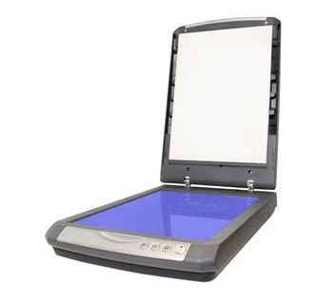
Digitizer
Digitizer is an input device, which converts analog information into a digital form. Digitizer can convert a signal from the television camera into a series of numbers that could be stored in a computer. They can be used by the computer to create a picture of whatever the camera had been pointed at.
Digitizer is also known as Tablet or Graphics Tablet because it converts graphics and pictorial data into binary inputs. A graphic tablet as digitizer is used for doing fine works of drawing and images manipulation applications.
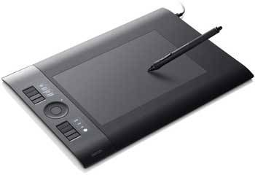
Microphone
Microphone is an input device to input sound that is then stored in digital form. The microphone is used for various applications like adding sound to a multimedia presentation or for mixing music.
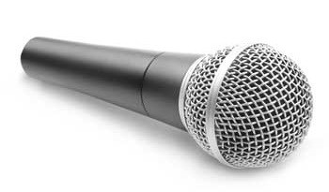
Magnetic Ink Card Reader (MICR)
MICR input device is generally used in banks because of a large number of cheques to be processed everyday. The bank’s code number and cheque number are printed on the cheques with a special type of ink that contains particles of magnetic material that are machine readable.
This reading process is called Magnetic Ink Character Recognition (MICR). The main advantage of MICR is that it is fast and less error prone.
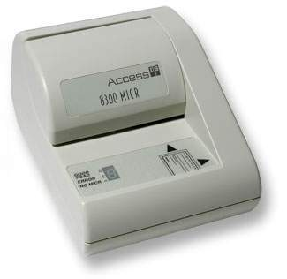
Optical Character Reader (OCR)
OCR is an input device used to read a printed text. OCR scans text optically character by character, converts them into a machine readable code and stores the text on the system memory.
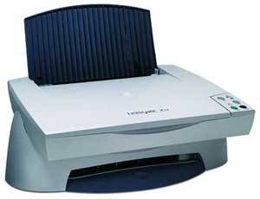
Bar Code Readers
Bar Code Reader is a device used for reading bar coded data (data in form of light and dark lines). Bar coded data is generally used in labelling goods, numbering the books, etc. It may be a hand-held scanner or may be embedded in a stationary scanner.
Bar Code Reader scans a bar code image, converts it into an alphanumeric value, which is then fed to the computer to which bar code reader is connected.
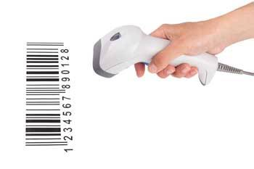
Optical Mark Reader (OMR)
OMR is a special type of optical scanner used to recognize the type of mark made by pen or pencil. It is used where one out of a few alternatives is to be selected and marked. It is specially used for checking the answer sheets of examinations having multiple choice questions.
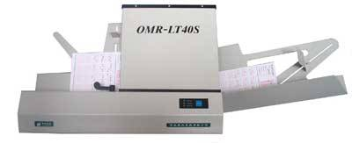

Following are few of the important output devices, which are used in Computer Systems:
- Monitors
- Graphic Plotter
- Printer
Monitors
Monitor commonly called as Visual Display Unit (VDU) is the main output device of a computer. It forms images from tiny dots, called pixels, that are arranged in a rectangular form. The sharpness of the image depends upon the number of the pixels.
There are two kinds of viewing screen used for monitors:
- Cathode-Ray Tube (CRT)
- Flat-Panel Display
Cathode-Ray Tube (CRT) Monitor
In the CRT, display is made up of small picture elements called pixels for short. The smaller the pixels, the better the image clarity or resolution. It takes more than one illuminated pixel to form whole character, such as the letter ‘e’ in the word help.
A finite number of characters can be displayed on a screen at once. The screen can be divided into a series of character boxes – fixed location on the screen where a standard character can be placed.
Most screens are capable of displaying 80 characters of data horizontally and 25 lines vertically. There are some disadvantages of CRT:
- Large in Size
- High power consumption
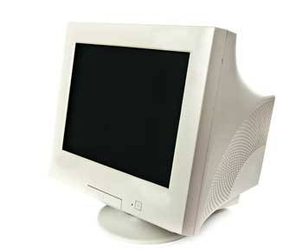
Flat-Panel Display Monitor
The flat-panel display refers to a class of video devices that have reduced volume, weight and power requirement compared to the CRT. You can hang them on walls or wear them on your wrists. Current uses for flat-panel displays include calculators, video games, monitors, laptop computer, graphics display.
The flat-panel display are divided into two categories:
- Emissive Displays – The emissive displays are devices that convert electrical energy into light. Example are plasma panel and LED (Light-Emitting Diodes).
- Non-Emissive Displays – The Non-emissive displays use optical effects to convert sunlight or light from some other source into graphics patterns. Example is LCD (Liquid-Crystal Device)
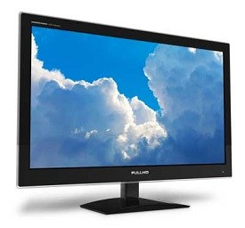
Printers
Printer is the most important output device, which is used to print information on paper.
There are two types of printers:
- Impact Printers
- Non-Impact Printers
Impact Printers
The printers that print the characters by striking against the ribbon and onto the paper, are called impact printers.
Characteristics of Impact Printers are the following:
- Very low consumable costs
- Impact printers are very noisy
- Useful for bulk printing due to low cost
- There is physical contact with the paper to produce an image
These printers are of two types:
- Character printers
- Line printers
Character Printers:
Character Printers are printers, which print one character at a time.
These are of further two types:
- Dot Matrix Printer (DMP)
- Daisy Wheel
Dot Matrix Printer
In the market, one of the most popular printer is Dot Matrix Printer because of their ease of printing features and economical price. Each character printed is in form of pattern of Dot’s and head consists of a Matrix of Pins of size(5*7, 7*9, 9*7 or 9*9) which comes out to form a character that is why it is called Dot Matrix Printer.
Advantages
- Inexpensive
- Widely Used
- Other language characters can be printed
Disadvantages
- Slow Speed
- Poor Quality
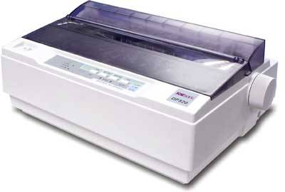
Daisy Wheel
Head is lying on a wheel and Pins corresponding to characters are like petals of Daisy (flower name) that is why it is called Daisy Wheel Printer. These printers are generally used for word-processing in offices which require a few letters to be send here and there with very nice quality representation.
Advantages
- More reliable than DMP’s
- Better quality
- The fonts of character can be easily changed.
Disadvantages
- Slower than DMP’s
- Noisy
- More expensive than DMP’s
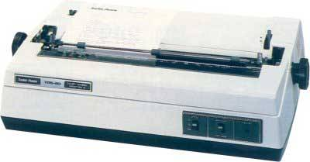
Line Printers
Line printers are printers, which print one line at a time.
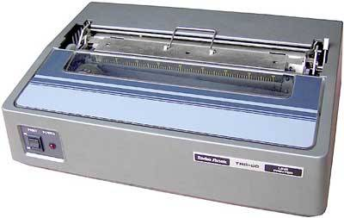
These are of further two types:
- Drum Printer
- Chain Printer
Drum Printer
This printer is like a drum in shape so it called drum printer. The surface of drum is divided into number of tracks. Total tracks are equal to size of paper, i.e., for a paper width of 132 characters, Drum will have 132 tracks. A character set is embossed on track. The different character sets available in market are 48 character set, 64 and 96 characters set. One rotation of drum prints one line. Drum Printers are fast in speed and prints between 300 to 2000 lines per minute.
Advantages
- Very high speed
Disadvantages
- Very expensive
- Characters fonts can not be changed
Chain Printer
In this printer, chain of character sets are used so it called Chain Printers. A standard character set may have 48, 64, 96 characters.
Advantages
- Character fonts can easily be changed.
- Different languages can be used with the same printer.
Disadvantages
- Noisy
- Do not have the ability to print any shape of characters.
Non-impact Printers
The printers that print the characters without striking against the ribbon and onto the paper are called Non-impact Printers. These printers print a complete page at a time, also called as Page Printers.
These printers are of two types:
- Laser Printers
- Inkjet Printers
Characteristics of Non-impact Printers:
- Faster than impact printers.
- They are not noisy.
- High quality.
- Support many fonts and different character size.
Laser Printers
These are non-impact page printers. They use laser lights to produce the dots needed to form the characters to be printed on a page.
Advantages
- Very high speed.
- Very high quality output.
- Gives good graphics quality.
- Supports many fonts and different character sizes.
Disadvantage
- Expensive.
- Cannot be used to produce multiple copies of a document in a single printing.
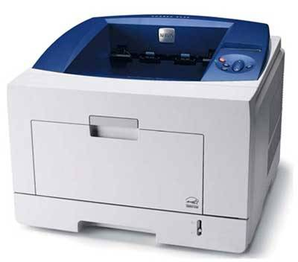
Inkjet Printers
Inkjet printers are non-impact character printers based on a relatively new technology. They print characters by spraying small drops of ink onto paper. Inkjet printers produce high quality output with presentable features.
They make less noise because no hammering is done and these have many styles of printing modes available. Color printing is also possible. Some models of Inkjet printers can produce multiple copies of printing also.
Advantages
- High quality printing
- More reliable
Disadvantages
- Expensive as cost per page is high
- Slow as compared to laser printer

3D printing
3D printing or additive manufacturing is a process of making three dimensional solid objects from a digital file.
The creation of a 3D printed object is achieved using additive processes. In an additive process an object is created by laying down successive layers of material until the object is created. Each of these layers can be seen as a thinly sliced horizontal cross-section of the eventual object.
3D printing is the opposite of subtractive manufacturing which is cutting out / hollowing out a piece of metal or plastic with for instance a milling machine.
3D printing enables you to produce complex shapes using less material than traditional manufacturing methods.
Applications of 3D Printing
3D printing encompasses many forms of technologies and materials as 3D printing is being used in almost all industries you could think of. It’s important to see it as a cluster of diverse industries with a myriad of different applications.
A few examples:
- braces in dentistry
- eyewear
- architectural scale models & maquettes(model or sketch)
- prosthetics(an artificial body part)
- movie props
- design (lamps, furniture etc)
- reconstructing fossils in paleontology(the branch of science concerned with fossil animals and plants)
- replicating ancient artifacts in archaeology(the study of human history)
- reconstructing bones and body parts in forensic pathology
- reconstructing heavily damaged evidence retrieved from a crime scene
How does 3D Printing Work
There are 3 main steps in 3D printing.
The first step is the preparation just before printing, when you design a 3D file of the object you want to print. This 3D file can be created using CAD software , with a 3D scanner or simply downloaded from an online marketplace. Once you have checked that your 3D file is ready to be printed , you can proceed to the second step.
The second step is the actual printing process. First, you need to choose which material will best achieve the specific properties required for your object. The variety of materials used in 3D printing is very broad. It includes plastics, ceramics, resins, metals, sand, textiles, biomaterials, glass, food and even lunar dust! Most of these materials also allow for plenty of finishing options that enable you to achieve the precise design result you had in mind, and some others, like glass for example, are still being developed as 3D printing material and are not easily accessible yet.
The third step is the finishing process. This step requires specific skills and materials. When the object is first printed, often it cannot be directly used or delivered until it has been sanded, lacquered or painted to complete it as intended.
The material chosen for the project will determine which printing methods are most suitable. Among these, the most commonly used techniques for each group of materials are described next.
Plotters & Their Types
A plotter is a special output device used to produce hard copies of large graphs and designs on paper, such as construction maps, engineering drawings, architectural plans and business charts. The plotter is either a peripheral component that you add to your computer system or a standalone device with its own internal processor.
Drum Plotter
A drum plotter is a pen plotter that wraps the paper around a drum with a pin feed attachment. The drum then rotates the paper as pens move across it and draw the image. It was the first output device used to print graphics and large engineering drawings. There are two types of drum plotters, external and internal. With an external drum plotter, the paper is wrapped around its external surface, while the internal drum plotter uses a sheet of paper wrapped around its internal surface.
Flat-Bed Plotter
A flat-bed plotter is a mechanical drafting device used with many CAD(Computer aided Design) programs for designers. The paper remains stationary on a flat surface while a pen moves across it horizontally and vertically. This plotter may use several different pen colors to create the graphics. The size of the graphic is limited to the size of the flat-bed plotter's surface.
Inkjet Plotter
The inkjet plotter creates an image by spraying small droplets of ink on to paper. A popular choice for advertising agencies and graphic designers, inkjet plotters are used generally for large outputs, such as banners and billboards and large signs often seen along roadsides. They are available in thermal or piezoelectric models. Thermal inkjet plotters use heat to apply droplets of ink, while piezoelectric plotters use charged crystals to apply the ink. Inkjet plotters typically produce better quality graphics than other plotter types.
Projectors(LCD/LED)
Projectors can be categorized by there by the technology used by it to project the content. The content can be an image or moving image and video. A projector can be used for study purpose in school, colleges and tuitions. For entertainment purpose at home as a home theatre and also for the gaming. Heres the difference between LCD and LED projector.
Basis: Technical Difference
LCD Projector: If a projector uses Liquid crystal Display than it is called an LCD Projector and there are two types of LCD projector
1.) A 3-chip LCD projector
2.) single-chip LCD projector
LCD projectors project light onto mirrors which split it up into its 3 primary colors: red, green and blue. The colors then pass through three separate glass panels (actually prisms), which is why this technology is referred to as 3LCD. The separate colors are then converged using another prism and projected on to the screen.
Features Of LCD Projector
1.) LCD Projectors are less expensive.
2.) LCD Projector has no moving parts.
3.) A single chip LCD projector is very budget friendly.
4.) A 3 chip LCD projector gives better saturation with minimum sound.
5.) LCD projectors are good for home theatres.
6.) LCD Projector produces less contrast level output.

LED Projector : A LED projector is just a light emitting diode. It has two lead semiconductor source of light. This type of projector converts electric energy into light directly.
The biggest advantage of LED is that the Light emitting Diodes in an LED projector have a much longer life than traditional projector lamps, rated at 10,000 or even 20,000 hours as opposed to 1,000 hours to 5,000 hours. As such, the LED light source is meant to last the entire life of the projector without ever needing to be replaced.
This is a big advantage because replacing traditional lamps can be a major expense in projector maintenance. There is no warm-up or cool-down time needed because the LEDs are much more energy efficient than traditional light sources. This reduces maintenance and operating costs.
Features Of LED Projectors.
1.) The life span of LED Projectors is over 20000 hours.
2.) The maintenance cost of LCD projectors is very low.
3.) power consumption is low.
4.) LCD projectors project better colours.
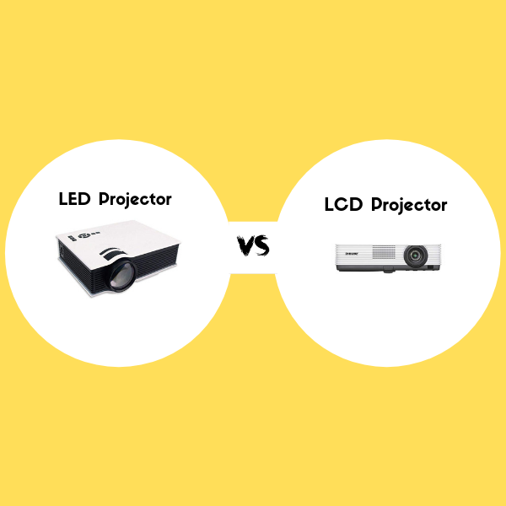

Computer Memory and its Types:
A memory is just like a human brain. It is used to store data and instructions. Computer memory is the storage space in the computer, where data is to be processed and instructions required for processing are stored. The memory is divided into large number of small parts called cells. Each location or cell has a unique address, which varies from zero to memory size minus one. Memory is primarily of three types −
- Cache Memory
- Primary Memory/Main Memory
- Secondary Memory

Cache Memory
Cache memory is a very high speed semiconductor memory which can speed up the CPU. It acts as a buffer between the CPU and the main memory. It is used to hold those parts of data and program which are most frequently used by the CPU. The parts of data and programs are transferred from the disk to cache memory by the operating system, from where the CPU can access them.
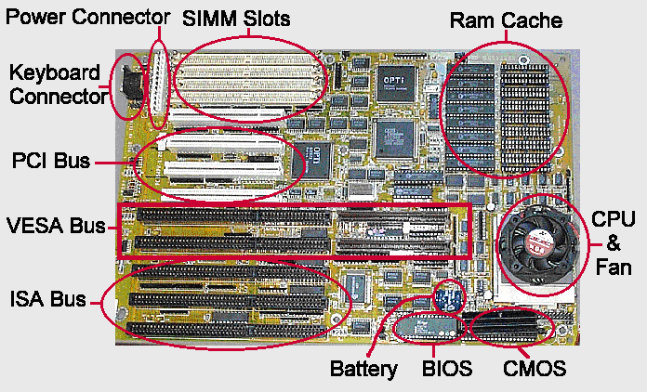

Advantages
The advantages of cache memory are as follows −
- Cache memory is faster than main memory.
- It consumes less access time as compared to main memory.
- It stores the program that can be executed within a short period of time.
- It stores data for temporary use.

Disadvantages
The disadvantages of cache memory are as follows −
- Cache memory has limited capacity.
- It is very expensive.

Primary Memory (Main Memory)
Primary memory holds only those data and instructions on which the computer is currently working. It has a limited capacity and data is lost when power is switched off. It is generally made up of semiconductor device. These memories are not as fast as registers. The data and instruction required to be processed resides in the main memory. It is divided into two subcategories RAM and ROM.
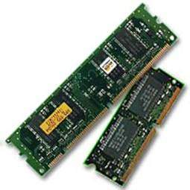

Characteristics of Main Memory
- These are semiconductor memories.
- It is known as the main memory.
- Usually volatile memory.
- Data is lost in case power is switched off.
- It is the working memory of the computer.
- Faster than secondary memories.
- A computer cannot run without the primary memory.

Secondary Memory
This type of memory is also known as external memory or non-volatile. It is slower than the main memory. These are used for storing data/information permanently. CPU directly does not access these memories, instead they are accessed via input-output routines. The contents of secondary memories are first transferred to the main memory, and then the CPU can access it. For example, disk, CD-ROM, DVD, etc.
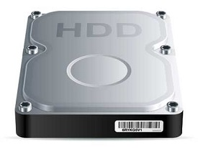

Characteristics of Secondary Memory
- These are magnetic and optical memories.
- It is known as the backup memory.
- It is a non-volatile memory.
- Data is permanently stored even if power is switched off.
- It is used for storage of data in a computer.
- Computer may run without the secondary memory.
- Slower than primary memories.

Types of RAM and ROM
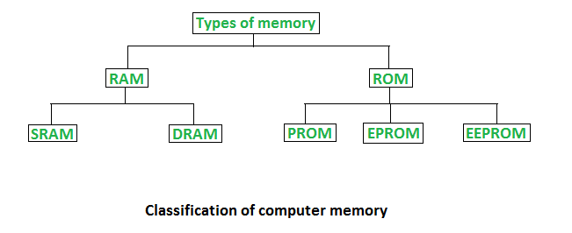
1. Random Access Memory (RAM) –
- It is also called as read write memory or the main memory or the primary memory.
- The programs and data that the CPU requires during execution of a program are stored in this memory.
- It is a volatile memory as the data loses when the power is turned off.
- RAM is further classified into two types- SRAM (Static Random Access Memory) and DRAM (Dynamic Random Access Memory).
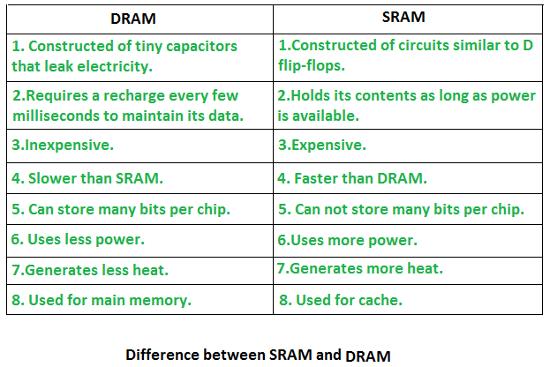
2. Read Only Memory (ROM) –
- Stores crucial information essential to operate the system, like the program essential to boot the computer.
- It is not volatile.
- Always retains its data.
- Used in embedded systems or where the programming needs no change.
- Used in calculators and peripheral devices.
- ROM is further classified into 4 types- ROM, PROM, EPROM, and EEPROM.

Types of Read Only Memory (ROM) –

- PROM (Programmable read-only memory) – It can be programmed by user. Once programmed, the data and instructions in it cannot be changed.

- EPROM (Erasable Programmable read only memory) – It can be reprogrammed. To erase data from it, expose it to ultra violet light. To reprogram it, erase all the previous data.
- EEPROM (Electrically erasable programmable read only memory) – The data can be erased by applying electric field, no need of ultra violet light. We can erase only portions of the chip.
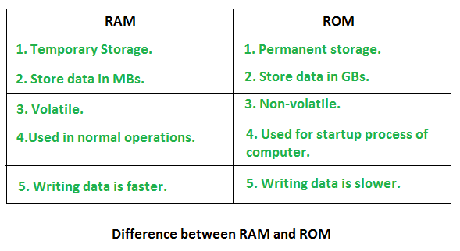
Memory Hierarchy Design and its Characteristics
Memory hierarchy is a concept that is necessary for the CPU to be able to manipulate data.
Computer memory is classified in the below hierarchy.
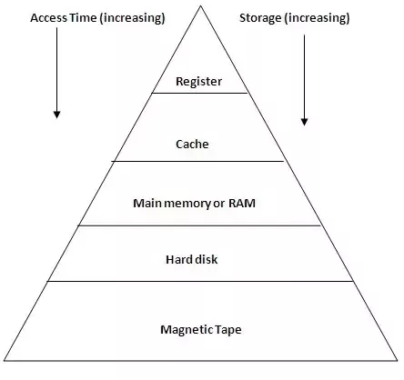

  - Internal register is for holding the temporary results and variables. Accessing data from
  - these registers is the fastest way of accessing memory.
2. Cache is used by the CPU for memory which is being accessed over and over again. Instead of pulling data every time from the main memory, it is put in cache for fast access. It is also a smaller memory, however, larger than internal register.
3. Main memory or RAM (Random Access Memory): It is a type of the computer memory and is a hardware component. It can be increased provided the operating system can handle it.
4. Hard disk: A hard disk is a hardware component in a computer. Data is kept permanently in this memory. Memory from hard disk is not directly accessed by the CPU, hence it is slower. As compared with RAM, hard disk is cheaper per bit.
5. Magnetic tape: Magnetic tape memory is usually used for backing up large data. The
memory access time is slower in magnetic tape and it usually takes few minutes to access a tape.

Storage Devices
Types of Removable Storage:
Magnetic storage media:
Magnetic media is coated with a magnetic layer which is magnetized in clockwise or anticlockwise directions. When the disk moves, the head interprets the data stored at a specific location in binary 1s and 0s at reading.
Examples: hard disks, floppy disks and magnetic tapes.
- Floppy Disk: A floppy disk is a flexible disk with a magnetic coating on it. It is packaged inside a protective plastic envelope. These are one of the oldest type of portable storage devices that could store up to 1.44 MB of data but now they are not used due to very less memory storage. A special type of floppy disk was made in the late 1980s. It could store 2.88 MB of data.

- Hard disk: A hard disk consists of one or more circular disks called platters which are mounted on a common spindle. Each surface of a platter is coated with a magnetic material. Both surfaces of each disk are capable of storing data except the top and bottom disk where only the inner surface is used. The information is recorded on the surface of the rotating disk by magnetic read/write heads. These heads are joined to a common arm known as access arm.

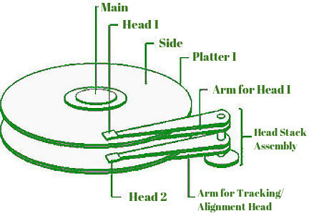

Hard disk drive components:
Most of the basic types of hard drives contains a number of disk platters that are placed around a spindle which is placed inside a sealed chamber. The chamber also includes read/write head and motors. Data is stored on each of these disks in the arrangement of concentric circles called tracks which are divided further into sectors. Though internal Hard drives are not very portable and used internally in a computer system, external hard disks can be used as a substitute for portable storage. Hard disks can store data upto several terabytes.

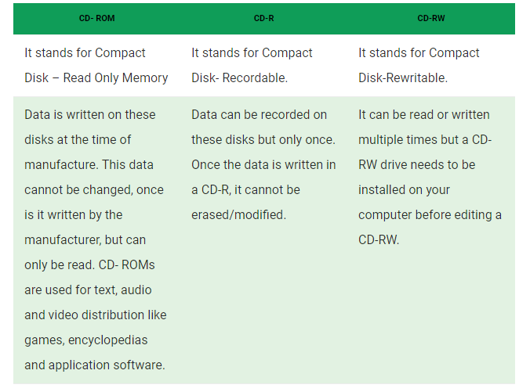
2. Optical storage media
In optical storage media information is stored and read using a laser beam. The data is stored as a spiral pattern of pits and ridges denoting binary 0 and binary 1.
Examples: CDs and DVDs
- Compact Disk: A Compact Disc drive(CDD) is a device that a computer uses to read data that is encoded digitally on a compact disc(CD). A CD drive can be installed inside a computer’s compartment, provided with an opening for easier disc tray access or it can be used by a peripheral device connected to one of the ports provided in the computer system. A compact disk or CD can store approximately 650 to 700 megabytes of data. A computer should possess a CD Drive to read the CDs. s

